**S3 cli commands**

Go to putty server and type ‘aws configure’. After that fill user details, available in IAM role ‘credentials’ tab, you will get secret access key.

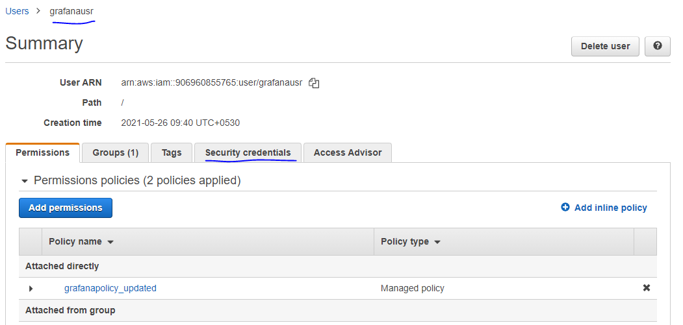

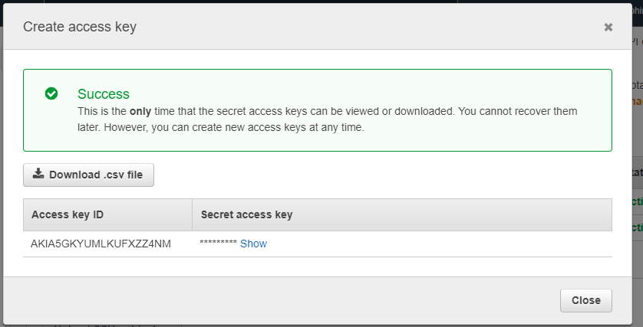

Once you fill these 2 information, rest information please leave as default.

$ aws s3 mb s3://mybucket || To create a new bucket || make_bucket: mybucket

$ aws s3 mb s3://mybucket --region ap-south-1 || To Create New S3 Bucket – in specific Region || make_bucket: mybucket

$ aws s3 rb s3://tgsbucket || To remove a bucket || remove_bucket: mybucket || It will work when bucket is empty

$ aws s3 rb s3://tgsbucket --force || To remove a bucket which contains objects || we are removing forcefully

$ aws s3 ls or aws s3 ls s3:// || To list all the s3 buckets

$ aws s3 ls s3://mybucket || To list all the objects within bucket 'mybucket'

$ aws s3 ls s3://tgsbucket --recursive --human-readable --summarize || to display total size of all objects in a S3 Bucket

$ aws s3 cp abhidata.txt s3://mybucket || To copy local file to S3 bucket

$ aws s3 cp abhidata.txt s3://tgsbucket/abhidata-new.txt || If you want to copy the abhidata.txt to a S3 bucket with a different name

$ aws s3 cp s3://mybucket/abhidata.txt . || To download a specific file from an S3 bucket.

$ aws s3 cp s3://mybucket/ . --recursive || Download All Files Recursively from a S3 Bucket (Using Copy)

$ aws s3 cp s3://mybucket/config/test.xml s3://backup-bucket || Copy a File from One Bucket to Another Bucket

$ aws s3 cp s3://mybucket s3://backup-bucket --recursive || Copy All Files Recursively from One Bucket to Another

$ aws s3 mv test.json s3://mybucket || Move a File from Local to S3 Bucket

$ aws s3 ls s3://mybucket/abhidata.txt || Move a File from S3 Bucket to Local